***Experiment 7 Output***

**Aim:** This experiment covers setting up and managing cloud-based relational databases using **PostgreSQL, Docker,** and **LocalStack**. The setup replicates real-world cloud database operations using containerized solutions.

***Accessing via Interactive shell***

***Creating Postgres Container***

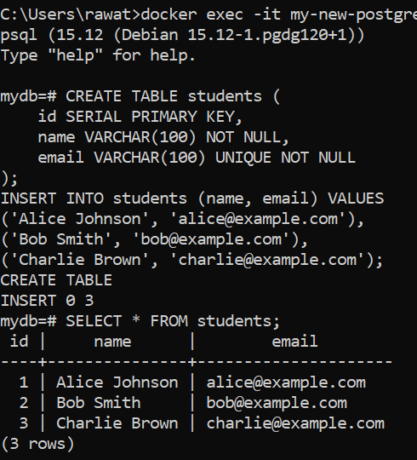.

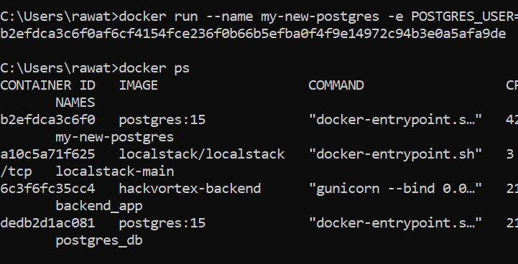

***Data Access & Queries***

***Fig 2: Creating Tables and Data insertion***

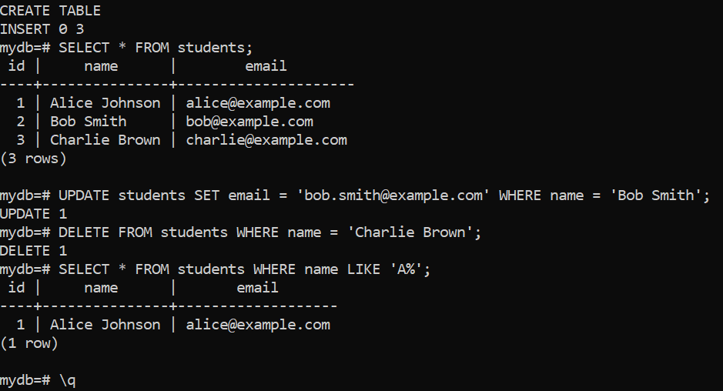

**Fig 1: Postgres Setup**

***Fig 3: Postgres Queries and Output***